# Data Designs

## Book a space at one of the 3 local restaurants (Harrogate, Leeds, Knaresborough Castle)

### Entity-relationship diagram:

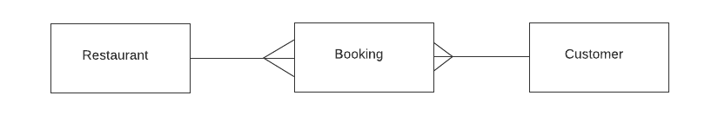

### Restaurant Data Dictionary:

|  |  |  |  |  |  |
| --- | --- | --- | --- | --- | --- |
| Name | Key | Description | Data Type | Required? | Validation |
| RestaurantID | Primary | Unique number to identify the restaurant that autoincrements | Integer | Yes | Yes (unique) |
| Location |  | Location of the store | String | Yes | Yes (one of 3 locations) |
| SeatsAvailable |  | Space available in restaurant | Integer | Yes | No |

### Booking Data Dictionary:

|  |  |  |  |  |  |
| --- | --- | --- | --- | --- | --- |
| Name | Key | Description | Data Type | Required? | Validation |
| BookingID | Primary | Unique number to identify the booking that autoincrements | Integer | Yes | Yes (unique) |
| RestaurantID | Foreign | Unique number to identify the restaurant that autoincrements | String | Yes | Yes (unique) |
| CustomerID | Foreign | Unique number to identify the customer that autoincrements | Integer | Yes | Yes (unique) |
| SeatsBooked |  | Seats booked in restaurant | Integer | Yes | Yes (pre-set, max of 8, min of 1) |
| Time |  | Time of booking | DateTime | Yes | Yes (can’t go below or above a certain time) |
| Date |  | Date of booking | DateTime | Yes | Yes (more than current date) |
| Extras |  | Additions to the regular booking (e.g child chair) | String | No | No |
| Extras Amount |  | Amount of each extra item | Integer | No | Yes (0 or more) |
| Paid |  | Has the customer paid or not | Boolean | No | No |

### Customer Data Dictionary:

|  |  |  |  |  |  |
| --- | --- | --- | --- | --- | --- |
| Name | Key | Description | Data Type | Required? | Validation |
| CustomerID | Primary | Unique number to identify the customer that autoincrements | Integer | Yes | Yes (unique) |
| CustomerName |  | Name of customer | String | Yes | Yes |
| PostCode |  | Post code of customer | String | Yes | Yes |
| Address |  | Address of customer | String | Yes | No |
| DateOfBirth |  | Date of birth of customer | Date | Yes | Yes |
| PhoneNumber |  | Number of the customer | String | Yes | Yes |

### Data Flow Diagram:

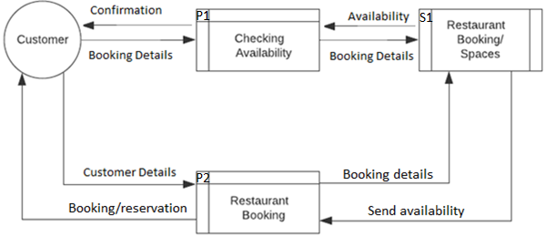

## Be able to pre-order a coffee for collection

### Entity-relationship Diagram:

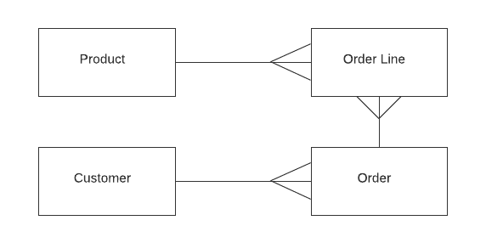

### Product Data Dictionary:

|  |  |  |  |  |  |
| --- | --- | --- | --- | --- | --- |
| Name | Key | Description | Data Type | Required? | Validation |
| ProductID | Primary | Unique Number to identify the product that autoincrements | Integer | Yes | Yes (unique) |
| ProductName |  | Name of product | String | Yes | No |
| ProductType |  | Type of product | String | Yes | Yes (must be coffee or baked good) |
| Hamperable |  | Can the product be in a customised hamper | Boolean | Yes | No |
| Quantity |  | Amount of the product | Integer | Yes | Yes (0 or more) |

### Order Line Data Dictionary:

|  |  |  |  |  |  |
| --- | --- | --- | --- | --- | --- |
| Name | Key | Description | Data Type | Required? | Validation |
| ProductID | Foreign (composite) | Unique Number to identify the product that autoincrements | Integer | Yes | Yes (unique) |
| OrderNum | Foreign (composite) | Unique Number to identify the order that autoincrements | Integer | Yes | No |
| Quantity |  | The amount of a product that autoincrements | Integer | Yes | Yes |
| Extras |  | Additions to the regular orders | String | No | Yes |

### Order Data Dictionary:

|  |  |  |  |  |  |
| --- | --- | --- | --- | --- | --- |
| Name | Key | Description | Data Type | Required? | Validation |
| OrderID | Primary | Unique Number to identify the order that autoincrements | Integer | Yes | Yes (unique) |
| CustomerID | Foreign | Unique Number to identify the customer that autoincrements | Integer | Yes | Yes (unique) |
| RestaurantID | Foreign | Unique number to identify the restaurant that autoincrements | Integer | Yes | Yes (unique) |
| Time |  | Time for the customer to pick up the order | DateTime | Yes | Yes (can’t go past certain time) |
| Date |  | Date of booking | DateTime | Yes | Yes (more than current date) |
| Paid |  | Has the customer paid or not | Boolean | No | No |

### Customer Data Dictionary:

|  |  |  |  |  |  |
| --- | --- | --- | --- | --- | --- |
| Name | Key | Description | Data Type | Required? | Validation |
| CustomerID | Primary | Unique number to identify the customer that autoincrements | Integer | Yes | Yes (unique) |
| CustomerName |  | Name of customer | String | Yes | Yes |
| PostCode |  | Post code of customer | String | Yes | Yes |
| Address |  | Address of customer | String | Yes | No |
| DateOfBirth |  | Date of birth of customer | Date | Yes | Yes |
| PhoneNumber |  | Number of the customer | String | Yes | Yes |

### Data Flow Diagram:

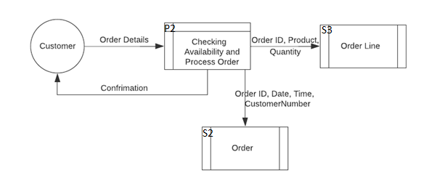

## Allow customer to pre-book online baking lessons

### Entity-relationship diagram:

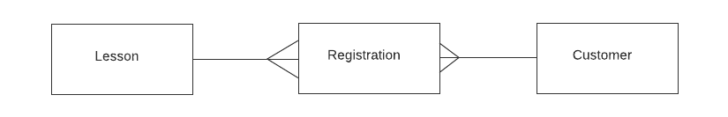

### Lesson Data Dictionary:

|  |  |  |  |  |  |
| --- | --- | --- | --- | --- | --- |
| Name | Key | Description | Data Type | Required? | Validation |
| LessonID | Primary | Unique number to identify the lesson that autoincrements | Integer | Yes | Yes (unique) |
| Time |  | Time the lesson is taking place | DateTime | Yes | No |
| Link (if dynamic) |  | Link to allow them to connect to the lesson | String | Yes | No |
| Topic |  | What the lesson is teaching so the user knows | String | Yes | No |

### Registration Data Dictionary:

|  |  |  |  |  |  |
| --- | --- | --- | --- | --- | --- |
| Name | Key | Description | Data Type | Required? | Validation |
| RegistrationID | Primary | Unique number to identify the registration that autoincrements | Integer | Yes | Yes (unique) |
| LessonID | Foreign | Unique number to identify the lesson that autoincrements | Integer | Yes | Yes (unique) |
| CustomerID | Foreign | Unique number to identify the customer that autoincrements | Integer | Yes | Yes (unique) |
| Time |  | Time of the lesson that the user chose | DateTime | Yes | Yes (pre-set times) |

### Customer Data Dictionary:

|  |  |  |  |  |  |
| --- | --- | --- | --- | --- | --- |
| Name | Key | Description | Data Type | Required? | Validation |
| CustomerID | Primary | Unique number to identify the customer that autoincrements | Integer | Yes | Yes (unique) |
| CustomerName |  | Name of customer | String | Yes | Yes |
| PostCode |  | Post code of customer | String | Yes | Yes |
| Address |  | Address of customer | String | Yes | No |
| DateOfBirth |  | Date of birth of customer | Date | Yes | Yes |
| PhoneNumber |  | Number of the customer | String | Yes | Yes |

### Data Flow Diagram:

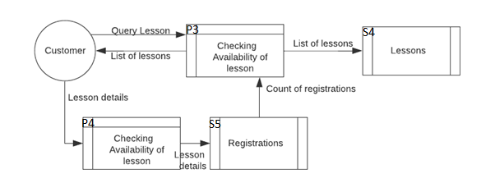

# Pre-order baked goods for collection

### Entity-relationship diagram:



### Customer Data Dictionary:

|  |  |  |  |  |  |
| --- | --- | --- | --- | --- | --- |
| Name | Key | Description | Data Type | Required? | Validation |
| CustomerID | Primary | Unique number to identify the customer that autoincrements | Integer | Yes | Yes (unique) |
| CustomerName |  | Name of customer | String | Yes | Yes |
| PostCode |  | Post code of customer | String | Yes | Yes |
| Address |  | Address of customer | String | Yes | No |
| DateOfBirth |  | Date of birth of customer | Date | Yes | Yes |
| PhoneNumber |  | Number of the customer | String | Yes | Yes |

### Order Data Dictionary:

|  |  |  |  |  |  |
| --- | --- | --- | --- | --- | --- |
| Name | Key | Description | Data Type | Required? | Validation |
| OrderID | Primary | Unique Number to identify the order that autoincrements | Integer | Yes | Yes (unique) |
| CustomerID | Foreign | Unique Number to identify the customer that autoincrements | Integer | Yes | Yes (unique) |
| RestaurantID | Foreign | Unique number to identify the restaurant that autoincrements | Integer | Yes | Yes (unique) |
| Time |  | Time for the customer to pick up the order | DateTime | Yes | Yes (can’t go past certain time) |
| Date |  | Date of booking | DateTime | Yes | Yes (more than current date) |
| Paid |  | Has the customer paid or not | Boolean | No | No |

### Order Line Data Dictionary:

|  |  |  |  |  |  |
| --- | --- | --- | --- | --- | --- |
| Name | Key | Description | Data Type | Required? | Validation |
| ProductID | Foreign (composite) | Unique Number to identify the product that autoincrements | Integer | Yes | Yes (unique) |
| OrderNum | Foreign (composite) | Unique Number to identify the order that autoincrements | Integer | Yes | No |
| Quantity |  | The amount of a product that autoincrements | Integer | Yes | Yes |
| Extras |  | Additions to the regular orders | String | No | Yes |

### Product Data Dictionary:

|  |  |  |  |  |  |
| --- | --- | --- | --- | --- | --- |
| Name | Key | Description | Data Type | Required? | Validation |
| ProductID | Primary | Unique Number to identify the product that autoincrements | Integer | Yes | Yes (unique) |
| ProductName |  | Name of product | String | Yes | No |
| ProductType |  | Type of product | String | Yes | Yes (must be coffee or baked good) |
| Hamperable |  | Can the product be in a customised hamper | Boolean | Yes | No |
| Quantity |  | Amount of the product | Integer | Yes | Yes (0 or more) |

### Data Flow Diagram:

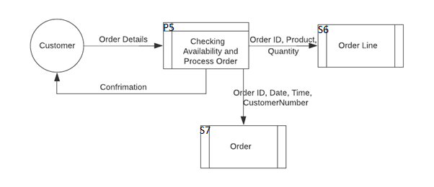

# Customisable baked goods hampers

### Entity-relationship diagram:



### Customer Data Dictionary:

|  |  |  |  |  |  |
| --- | --- | --- | --- | --- | --- |
| Name | Key | Description | Data Type | Required? | Validation |
| CustomerID | Primary | Unique number to identify the customer that autoincrements | Integer | Yes | Yes (unique) |
| CustomerName |  | Name of customer | String | Yes | Yes |
| PostCode |  | Post code of customer | String | Yes | Yes |
| Address |  | Address of customer | String | Yes | No |
| DateOfBirth |  | Date of birth of customer | Date | Yes | Yes |
| PhoneNumber |  | Number of the customer | String | Yes | Yes |

### Order Data Dictionary:

|  |  |  |  |  |  |
| --- | --- | --- | --- | --- | --- |
| Name | Key | Description | Data Type | Required? | Validation |
| OrderID | Primary | Unique Number to identify the order that autoincrements | Integer | Yes | Yes (unique) |
| CustomerID | Foreign | Unique Number to identify the customer that autoincrements | Integer | Yes | Yes (unique) |
| RestaurantID | Foreign | Unique number to identify the restaurant that autoincrements | Integer | Yes | Yes (unique) |
| Time |  | Time for the customer to pick up the order | DateTime | Yes | Yes (can’t go past certain time) |
| Date |  | Date of booking | DateTime | Yes | Yes (more than current date) |
| Paid |  | Has the customer paid or not | Boolean | No | No |

### Order Line Data Dictionary:

|  |  |  |  |  |  |
| --- | --- | --- | --- | --- | --- |
| Name | Key | Description | Data Type | Required? | Validation |
| ProductID | Foreign (composite) | Unique Number to identify the product that autoincrements | Integer | Yes | Yes (unique) |
| OrderNum | Foreign (composite) | Unique Number to identify the order that autoincrements | Integer | Yes | No |
| Quantity |  | The amount of a product that autoincrements | Integer | Yes | Yes |
| Extras |  | Additions to the regular orders | String | No | Yes |

### Product Data Dictionary:

|  |  |  |  |  |  |
| --- | --- | --- | --- | --- | --- |
| Name | Key | Description | Data Type | Required? | Validation |
| ProductID | Primary | Unique Number to identify the product that autoincrements | Integer | Yes | Yes (unique) |
| ProductName |  | Name of product | String | Yes | No |
| ProductType |  | Type of product | String | Yes | Yes (must be coffee or baked good) |
| Hamperable |  | Can the product be in a customised hamper | Boolean | Yes | No |
| Quantity |  | Amount of the product | Integer | Yes | Yes (0 or more) |

### Data Flow Diagram:

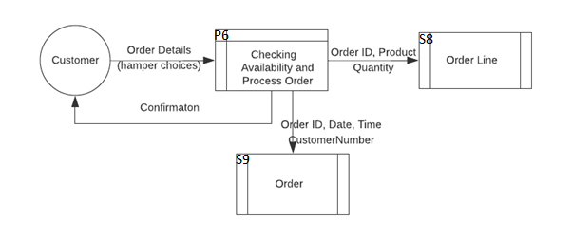

# Creating customer accounts to speed up re-ordering

### Entity-relationship diagram:

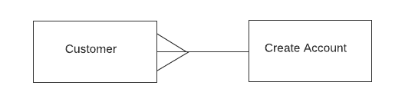

### Customer Data Dictionary:

|  |  |  |  |  |  |
| --- | --- | --- | --- | --- | --- |
| Name | Key | Description | Data Type | Required? | Validation |
| CustomerID | Primary | Unique number to identify the customer that autoincrements | Integer | Yes | Yes (unique) |
| CustomerName |  | Name of customer | String | Yes | Yes |
| PostCode |  | Post code of customer | String | Yes | Yes |
| Address |  | Address of customer | String | Yes | No |
| DateOfBirth |  | Date of birth of customer | Date | Yes | Yes |
| PhoneNumber |  | Number of the customer | String | Yes | Yes |

### Creating Account Data Dictionary:

|  |  |  |  |  |  |
| --- | --- | --- | --- | --- | --- |
| Name | Key | Description | Data Type | Required? | Validation |
| CustomerID | Primary | Unique number to identify the customer that autoincrements | Integer | Yes | Yes (unique) |
| CustomerName |  | Name of customer | String | Yes | Yes |
| PostCode |  | Post code of customer | String | Yes | Yes |
| Address |  | Address of customer | String | Yes | No |
| DateOfBirth |  | Date of birth of customer | Date | Yes | Yes |
| PhoneNumber |  | Number of the customer | String | Yes | Yes |
| Username |  | Username for the account so the user can login | String | Yes | Yes |
| Password |  | Password for the account so the user can login | String | Yes | Yes (num, special character, upper and lower case) |

### Data Flow Diagram:

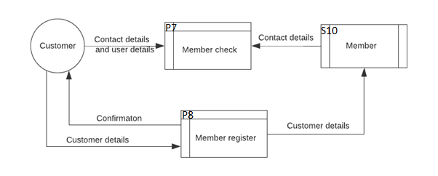

# Social media posting/sharing features (‘Rate my cake’)

### Entity-relationship diagram:

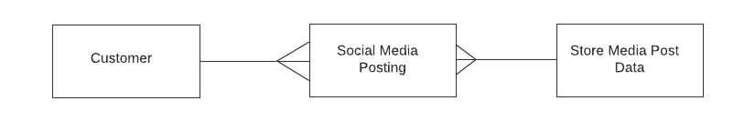

### Customer Data Dictionary:

|  |  |  |  |  |  |
| --- | --- | --- | --- | --- | --- |
| Name | Key | Description | Data Type | Required? | Validation |
| CustomerID | Primary | Unique number to identify the customer that autoincrements | Integer | Yes | Yes (unique) |
| CustomerName |  | Name of customer | String | Yes | Yes |
| PostCode |  | Post code of customer | String | Yes | Yes |
| Address |  | Address of customer | String | Yes | No |
| DateOfBirth |  | Date of birth of customer | Date | Yes | Yes |
| PhoneNumber |  | Number of the customer | String | Yes | Yes |

### Social Media Post Data Dictionary:

|  |  |  |  |  |  |
| --- | --- | --- | --- | --- | --- |
| Name | Key | Description | Data Type | Required? | Validation |
| CustomerName | Foreign | Name of customer | String | No | Yes |
| PostID | Primary | Unique number to identify the social media post that autoincrements | Integer | Yes | Yes |
| Date |  | Date the post was made | DateTime | Yes | Yes |
| Time |  | Time the post was made | DateTime | Yes | Yes |
| Username | Foreign | Username of who posted | String | Yes | Yes |
| CustomerID | Foreign | Unique number to identify the customer that autoincrements | Integer | Yes | Yes (unique) |
| Post |  | The text that the post will contain | String | Yes | No |

### Data Flow Diagram:

